2026 CAIA Level II ERRATA Printed Version
As of 10/15/2025

LII Section1.2_question14
14. ABC is a U.S. endowment that has previously invested only a marginal portion of its portfolio in alternative investments. ABC is considering allocating more funds to alternative investments, including hedge funds, but is afraid of the negative effects that the illiquidity of some of these alternative assets may have on the riskiness of its portfolio. To this end, ABC hires a consultant to determine, among other issues, the effects of lockup periods on returns, the costs of liquidity risk during periods of market stress, how to manage liquidity risks, the potential effects of gates on investors, as well as the effects that the smoothing of data reported by a number of alternative assets may have on allocations to these investments. The consultant has just submitted a report to ABC addressing these questions.
At the end of the report, the consultant expresses that “… To the extent that certain alternative investments have smoothed returns or net asset values that are reported with a time lag, liquid alternatives and traditional assets will decline in allocation rapidly during times of crisis.” What is the underlying principle of this analysis?
Should be: illiquid
Solution:
In the case of relatively illiquid investments (e.g., certain alternative investments such as private equity and hedge funds), the net asset value adjusts slowly to changes in public market valuation. As a result, in periods of crisis, prices of liquid assets decline rapidly and investors may react by only rebalancing within the liquid assets, while slowly changing allocations to relatively illiquid alternative investments (by modifying the size of future commitments).
LII Section 9.2.1. Page 441
Original:
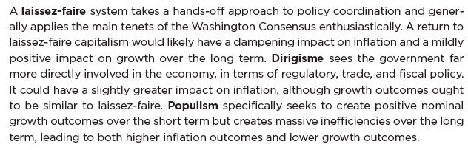
Last sentence should be:
Populism specifically seeks to create positive nominal growth outcomes over the short term but creates massive inefficiencies over the long term, leading to both higher inflation outcomes and lower growth outcomes relative to laissez-faire and dirigisme.

